1. So far we understood that to write a lambda expression, we need a function interface which helps compiler to know about   
   **NOTE**: Start from the method header from left to right and eventually return type.
   1. The return type.
   2. The access specifier.
   3. The method name.
   4. The # of parameters.
   5. The type of each parameter.
2. 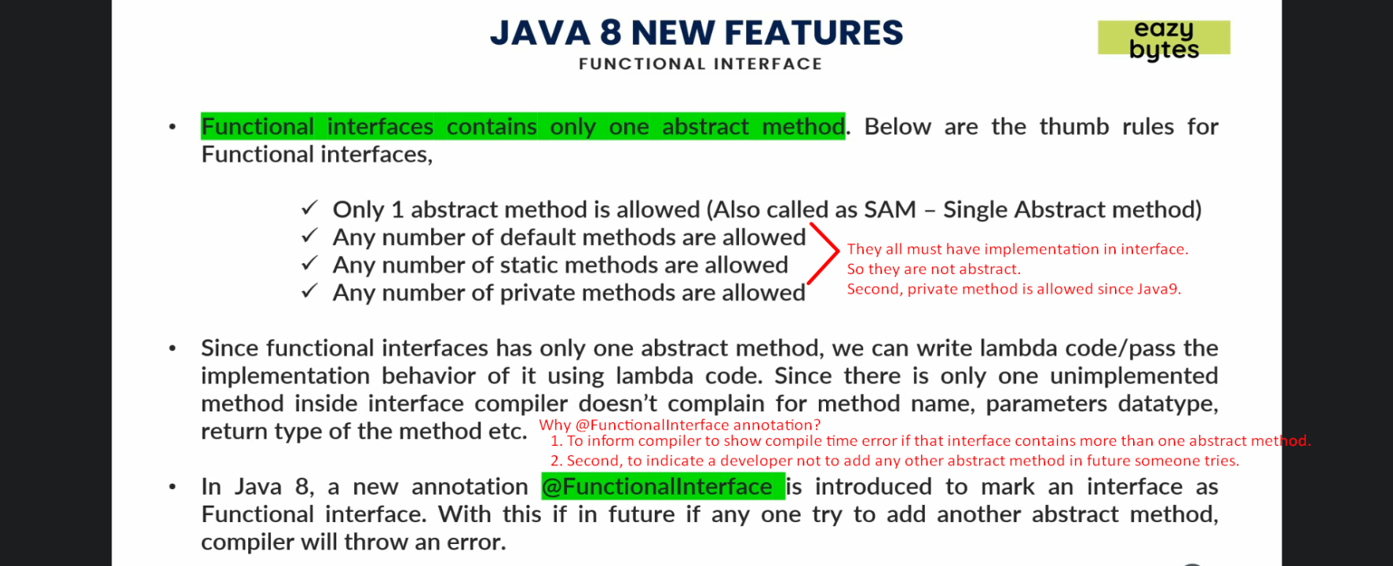
3. 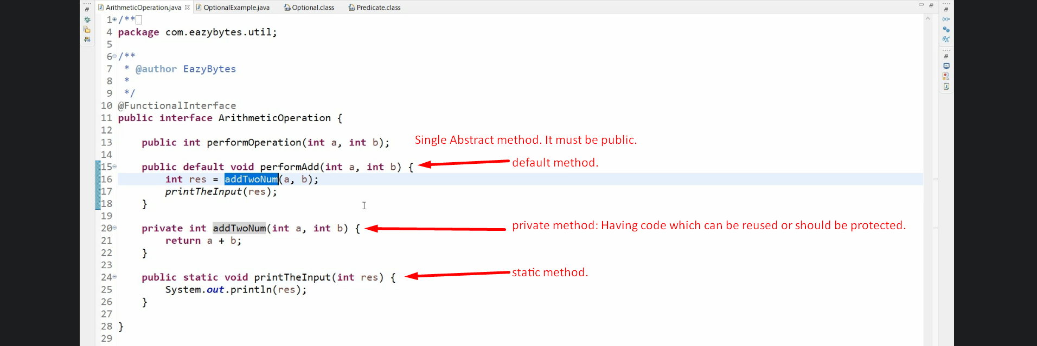
4. 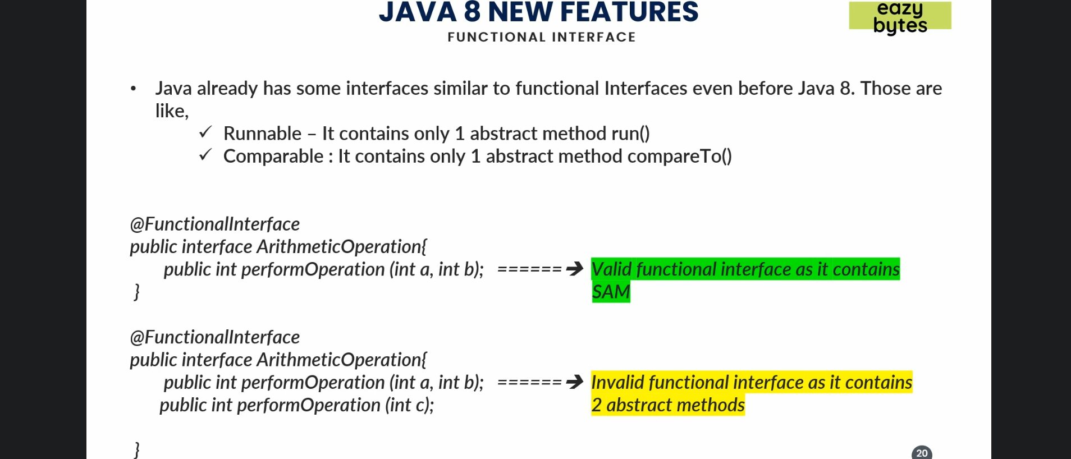
5. 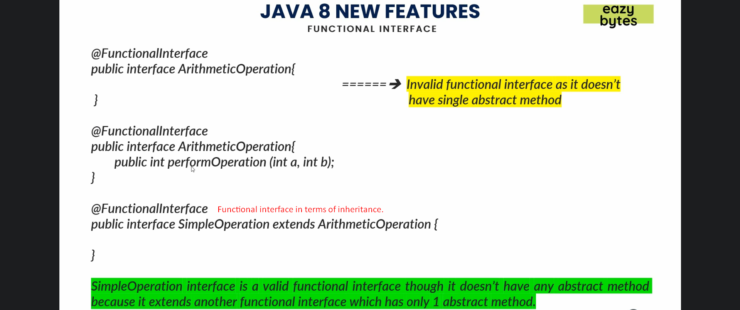
6. 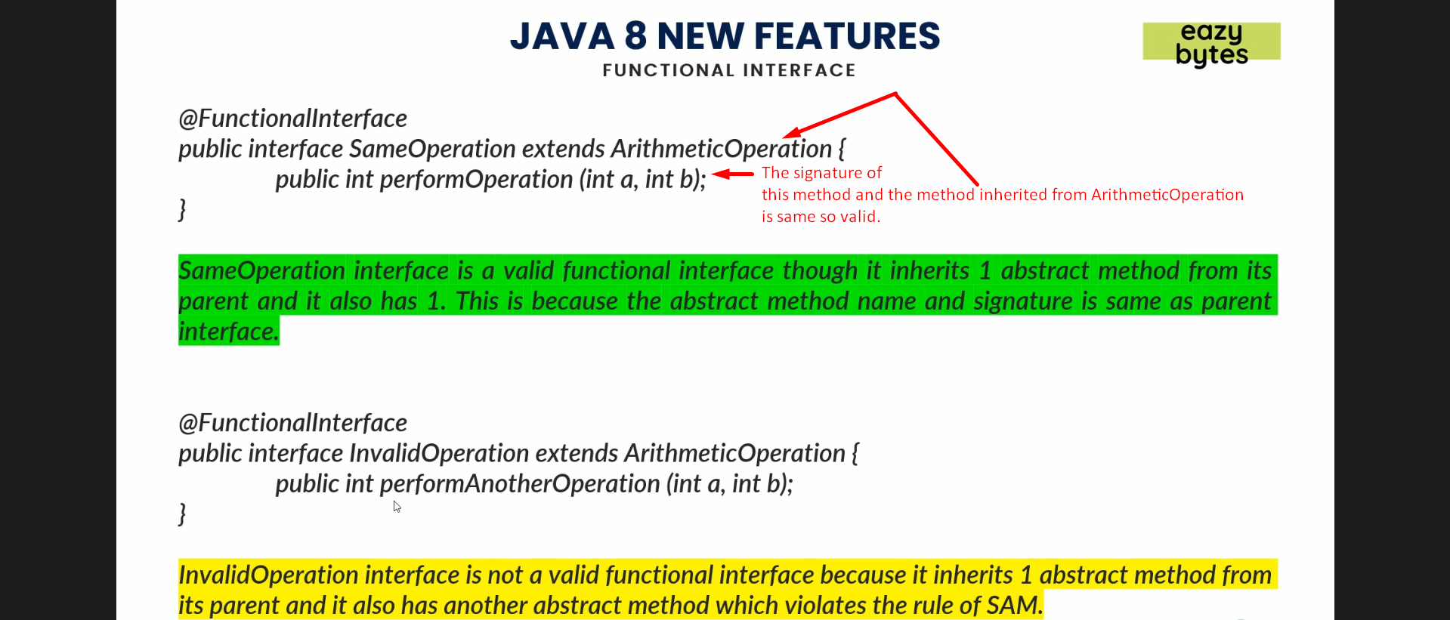
7. 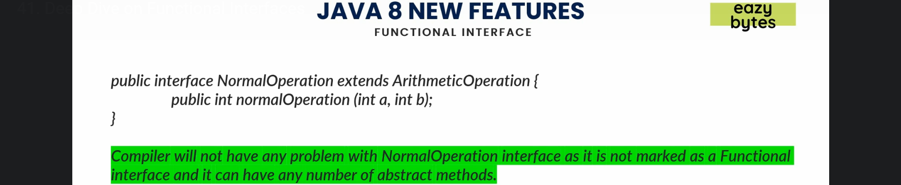
8. 